Milestone Two
Data Understanding and Data Preparation

Michael Surdek
Southern New Hampshire University
DAT 690: Capstone in Data Analytics
Professor Arman Kanooni
September 11, 2022
Data Understanding: Data Selection
Prior to making any decisions regarding data preparation for descriptive and predictive models, the contents and structure of the available data must be thoroughly examined in the data understanding phase. The data set provided on GE’s customers includes over 80 fields that generally consist of usage, coverage, demographic, and personal information. This original data is enough to serve alone as the foundation for a predictive model that can predict whether or not a customer is likely to churn. The final inputs to the model will either be selected from the original data, potentially untouched or transformed in certain ways, or be engineered through techniques such as deriving attributes and dimensionality reduction.
To better understand the provided data set, the fields can be organized into separate types of variables. These groups include identifier, target, usage, coverage, subscription, equipment, demographic, and location variables. Further, many demographic fields are contained as both dichotomized binary attributes as well as an overall categorical atribute. An example of this is occupation, which has individual yes/no fields for professor, self-employed, etc. but also has a single label field. In a logistic regression model, a categorical field is automatically dichotomized, so there will only be an advantage in using the binary fields if some should be excluded. All of the fields besides those just mentioned and the location variables are numeric. Before deciding whether or not to include these variables, it is important to explore their distributions, their relationships to the target, and their associations with each other.
Data Understanding: Data Exploration
To better understand these numeric attributes, it will be useful to calculate summary statistics such as means and standard deviations and to visualize distributions and relationships between the variables. Knowledge gained from this data exploration will guide the strategy and choices of the data preparation phase that precedes and accompanies the development of the models. The summary() function in R provides a quick view of each variable’s min/max, mean/median, and quartile values. It also provides important information about missing values in the data, which can be addressed in the data preparation phase.
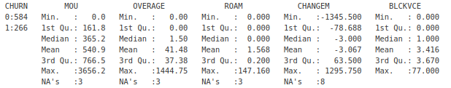
Another way to explore the data further is to visualize the distribution of each variable, particularly the distributions of both customers who have churned and those who have not. The field MOU, or mean monthly minutes, is one that was shown to be especially important for predicting churn in the pilot model. Visualizing its distribution across the target groups shows exactly why. Customers who have higher usage values, say above 800 minutes, are much less likely to be in the churned group.
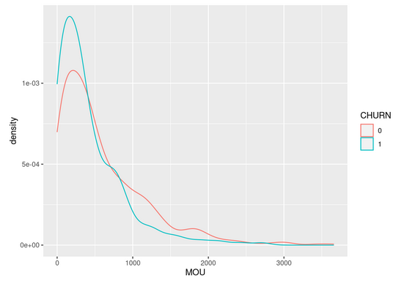
Data Understanding: Data Correlation
Finally, another key step in understanding the data involves uncovering correlation between attributes. This is important because including multiple correlated variables as inputs to the model will improperly weight that information and lead to inaccurate results such as overfitting. Relationships between the numeric fields can be visualized in a correlation matrix.
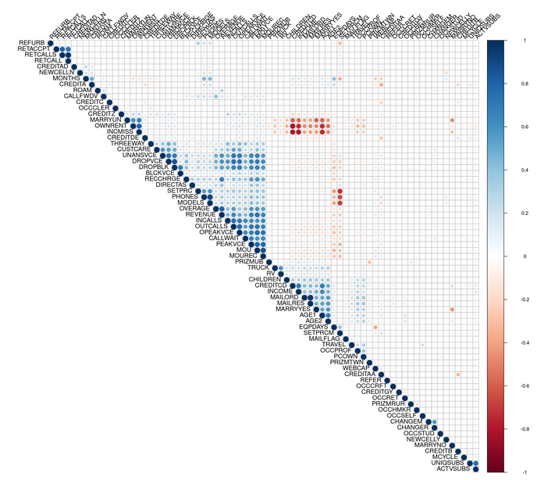
There is a lot of information in this single chart, but the main takeaways stem from the areas that are significantly red and blue. The large blue triangle shows that the usage variables are highly correlated with each other. For example, a higher number of outbound calls is associated with a higher number of unanswered calls. The smaller blue triangle involves personal information and shows that poor credit and income levels are associated with age, among other things. Finally, the larger red rectangle is a result of missing data signifiers and the data fields themselves, which will have to be handled in the data preparation phase.
Data Preparation: Data Cleaning
Now that the provided data is better understood, a strategy can be developed for how to manage various data types and areas of missing data. Missing data is encoded in multiple ways. Some fields include null values, whereas others fill missing values with zeroes and include a separate column which signifies that the value is actually missing. Since a logistic regression model cannot handle missing values, and treating something like a missing income value as 0 is not appropriate, it is necessary to resolve this issue with data preparation. Some techniques suitable for this scenario are exlcuding missing rows, imputing missing values, or binning (categorizing) the numeric fields with an additional “missing” category. Additionally, the data set will require some minor cleaning for things like incorrect column names and converting the target variable from numeric to a factor.
Data Preparation: Data Construction
Once the data is cleaned so that every field is accurately labelled and contains only the appropriate information, the rest of the data preparation and the subsequent returns to this phase will revolve around increasing predictive performance through feature engineering. This process comes in many forms, but the two main ones for this project will be deriving attributes and dimensionality reduction. Deriving attributes involves transforming information from the original data into a more useful form. For example, there is a ‘Communications Service Area’ field that is essentially a customer’s area code, but it also includes 3 letter codes for the customer’s general region and specific area, such as NYCBRO917, where NYC is New York City and BRO is Brooklyn. In the pilot project, I found that using the customer’s general location such as NYC is a better predictor of churn than the area code itself.
Dimensionality reduction, such as principal component analysis, is similar to deriving attributes, but the goal is to convert the information from numerous fields into a single value that encapsulates the important aspects of the original values. For example, all of the coverage variables could be reduced to a single value that describes a customer’s overall quality of coverage. It is possible that this piece of information will be a better predictor of churn than any of the individual coverage fields themselves.

